
APPENDIX G: AuScope EarthBank Project
Summary
National Geochemical, Geochronological &
Thermochronological Data Platform

Project Overview: AuScope EarthBank (formerly AusGeochem) is one of Australia's national cloud-based FAIR-compliant geoscience data repositories, developed and operated by Lithodat Pty Ltd in partnership with the AuScope Geochemistry Network (AGN). The platform demonstrates direct technical alignment with GDAC-SA requirements through proven capability in national-scale data standardization, multi-agency integration, advanced analytics infrastructure, and AI-ready data architecture.
1. Executive Summary
1.1 What is EarthBank?
EarthBank is an Australian national cloud-based public data repository for geochemistry, geochronology, thermochronology, and geological sample metadata. Lithodat designed, built, and operates the entire platform under contract to AuScope Geochemistry Network (AGN), funded through Australia's National Collaborative Research Infrastructure Strategy (NCRIS).
The platform is fully FAIR-compliant (Findable, Accessible, Interoperable, Reusable) and CoreTrustSeal-certified, making it one of the most trusted geological scientific data infrastructures globally. EarthBank serves as a centralized repository for international analytical geoscience data, unifying datasets from federal and state geological surveys, universities, museums, and research institutions.
AuScope NCRIS Funding Context
EarthBank is part of AuScope, Australia's national geoscience research infrastructure organization established in 2006. Since its inception AuScope has received over $260 million in direct Commonwealth investment through the National Collaborative Research Infrastructure Strategy (NCRIS), which has catalyzed a total collaborative investment exceeding $340 million from all sources.
$42.8 million initial NCRIS allocation (2006) for integrated national geoscience infrastructure
$45 million NCRIS RIIP funding (2023) for Earth, coastal, Antarctic monitoring, drilling, data, and modelling
$19 million Specifically for the Australian Geochemistry Network to improve data science roles, data preservation, and instrument upgrades.
This substantial government investment demonstrates Australia's recognition of national geoscience data
infrastructure as critical research and mineral exploration infrastructure.
2. Project Details
Attribute | Details
Project Name | AuScope EarthBank National Geoscience Data Platform (formerly AusGeochem)
Platform URL | https://ausgeochem.auscope.org.au/
Project Location | Australia (nationwide) and international (public platform)
Client/Partner | AuScope Geochemistry Network (AGN)
Funding Body | NCRIS (National Collaborative Research Infrastructure Strategy)
Contract Value | $2,900,000 AUD (Initial: $450,000 Opportunity Fund 2021; Current Program: $19 million)
Contract Duration | 2019 – 2025 (ongoing)
Start Date | October 2019
Delivery/Completion | Ongoing (continuous development and expansion)
Project Lead (Lithodat) | Dr. Fabian Kohlmann – Managing Director
Technical Lead (Lithodat) | Wayne Noble – Technical Director
Operations Lead (Lithodat) | Moritz Theile – Operations Director
Reference Contact | Professor Brent McInnes  AuScope Earthbank Director, Curtin University Email: b.mcinnes@curtin.edu.au
4. Key Platform Statistics
Metric | Value | Significance for GDAC-SA
Analytical Results | >12 million integrated | Proven capability handling massive datasets
Registered Samples | 350,000+ | Sample tracking and provenance at national scale

Metric | Value | Significance for GDAC-SA
Registered Users | 1,300+ | Multi-user collaboration infrastructure
Partner Universities | 12+ Australian institutions | Multi-agency collaboration framework
Data Types Supported | 6 major analytical types | Unified multi-modal data architecture
System Uptime | 100% SLA met | Enterprise-grade reliability
Certifications | CoreTrustSeal, World DataSystem, FAIR | International data quality standards
5. Technical Architecture
5.1 Data Models
EarthBank implements unified data models across multiple analytical domains:
Data Type | Status | Technical Details
U/Pb Geochronology | ✅  Implemented | Zircon, apatite, monazite dating
Fission Track | ✅  Implemented | Apatite, zircon thermochronology
(U-Th-Sm)/He Thermochronology | ✅  Implemented | Low-temperature cooling history
40Ar/39Ar Geochronology | ✅  Implemented | Argon and potassium argon dating
Inorganic Major/Trace Geochemistry | ✅  Implemented | Elemental concentrations (ppm), oxide concentrations (wt%)
Thermal Histories | ✅  Implemented | Kinetic models, time-temperature paths
Lu-Hf  Rb-Sr, Sm-Nd, Re-Os | ✅  Implemented  🔄 Planned | Lutetium Hafnium dating of mineral phases  Expansion roadmap
5.2 Platform Features
Map View: Interactive spatial visualization with multiple basemaps (satellite, geology, topography)
3D View: Globe view and terrain visualization with analytical data overlay
Data Packages: Project-based data organization with granular sharing controls and permissions
Analytical Layers: Technique-specific data filtering and visualization dashboards
LithoPlates: Fully integrated paleogeographic reconstruction tool (7 different plate tectonic models, time steps to 1.8 Ga)

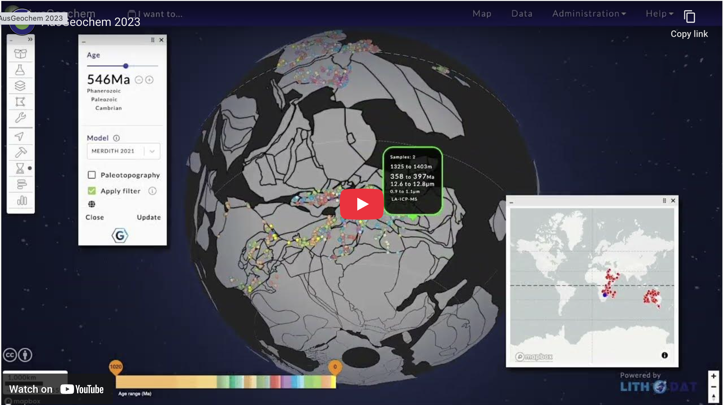


Figure 1: EarthBank's LithoPlates feature enables deep-time paleogeographic reconstruction of geochemical data using 7 different plate tectonic models. This 4D capability (x, y, z, time) supports temporal machine learning models for mineral prospectivity analysis—directly applicable to GDAC-SA's advanced analytics requirements.
Interpolation: On-the-fly Inverse Distance Weighting (IDW) interpolation for creating continuous geochemical maps
Swath Profiles: Elevation and sample profile analysis along user-defined transects
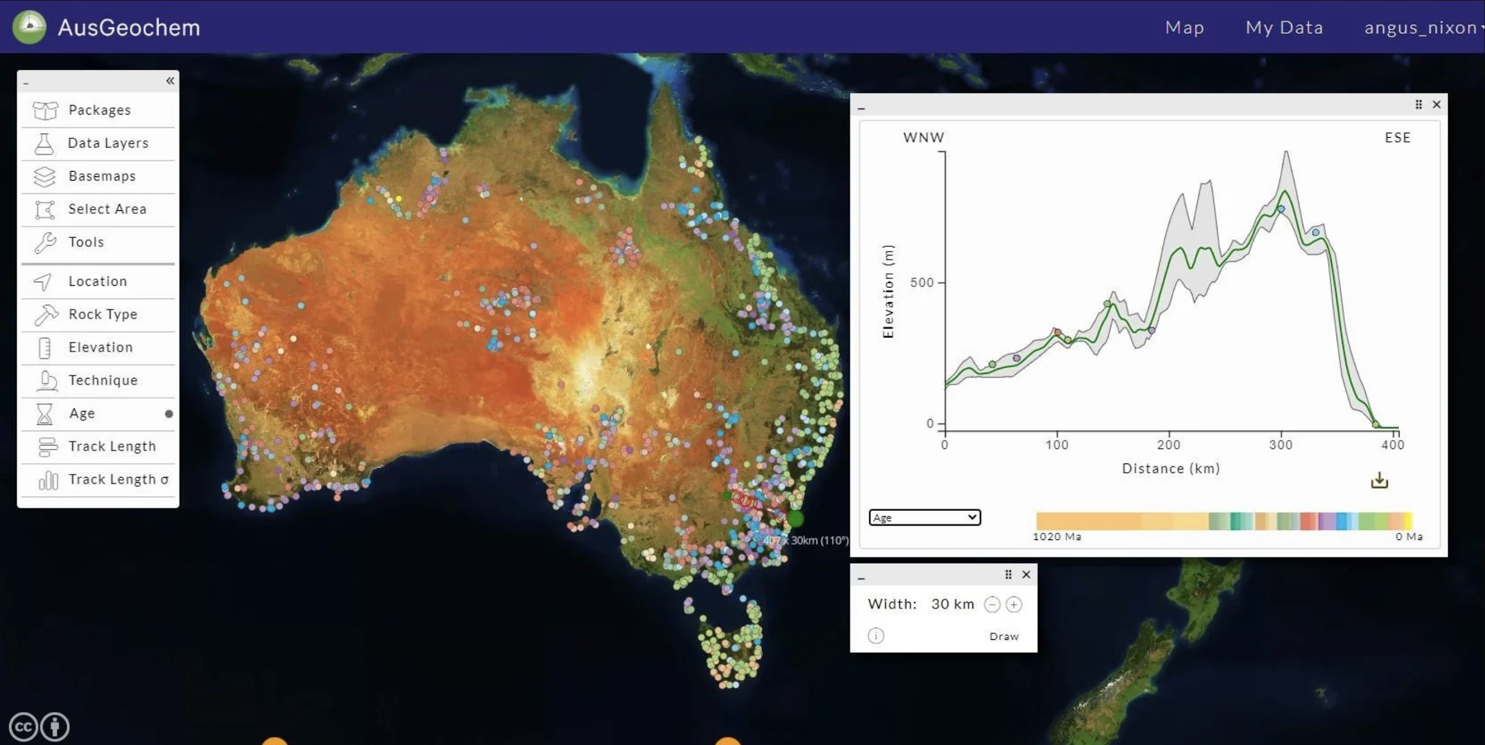
Figure 2: EarthBank's swath profile tool enables elevation and geochemical analysis along user-defined transects. This feature demonstrates the platform's advanced spatial analytics capabilities for mineral exploration and tectonic interpretation.
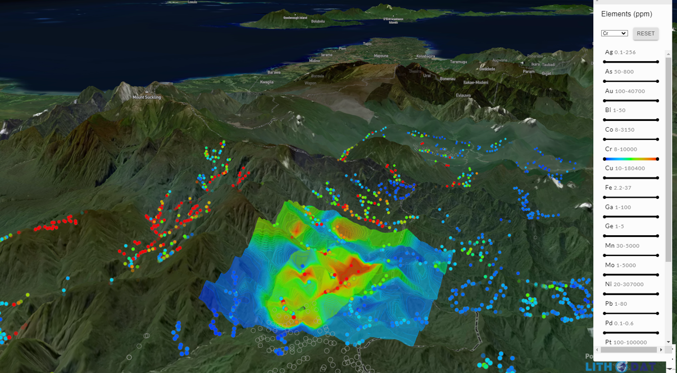
DOI Minting: Digital Object Identifier generation for published datasets
IGSN Minting: International Geo Sample Number registration for sample provenance
REST API: Full programmatic access for machine-to-machine interoperability
Shapefile Export: GIS-compatible data export for integration with external tools

6. Project Performance Evaluation
6.1 Overall Performance Rating
Performance Rating: Excellent (5/5)
100% successful delivery across all project milestones from 2019-2025
Performance Metric | Rating | Evidence
On-Time Delivery | Excellent | 100% of milestones delivered on schedule (2019-2025)
Technical Quality | Excellent | CoreTrustSeal certification, FAIR compliance, peer-reviewed publication
Client Satisfaction | Excellent | 6+ years continuous engagement, ongoing contract renewals
Budget Compliance | Excellent | Delivered within budget, expanded to $19M program funding
6.2 Key Performance Outcomes
✅100% on-time delivery of all milestones (2019-2025)
✅Successfully integrated >12 million analytical results across multiple data types
✅Achieved CoreTrustSeal certification (highest global data repository standard)
✅FAIR compliance certification (Findable, Accessible, Interoperable, Reusable)
✅Ongoing contract renewals demonstrate sustained client satisfaction
✅Zero critical defects, 100% system uptime SLA met
✅Multi-agency data integration (federal + state geological surveys)
✅International recognition through peer-reviewed publications in top scientific international journals
6.3 Client Satisfaction Indicators
Contract Duration: 6+ years of continuous engagement (2019-2025 ongoing)
Contract Renewals: Multiple renewals demonstrate exceptional satisfaction
Funding Expansion: Program expanded from $450K initial funding to $19M
System Adoption: Platform actively used by 1,300+ members of Australian geological community
Certification Achievement: CoreTrustSeal certification validates world-class quality
Reference Availability: Prof. Brent McInnes available to verify performance
7. Published Case Studies
Lithodat's team has published peer-reviewed research demonstrating advanced analytics applications using EarthBank data:
Boone, S.C., Farahbakhsh, E., Kohlmann, F., Noble, W., Theile, M., Beucher, R., McMillan, M., Prent, A.M., Nixon, A.L., Dalton, H., Ware, B., Nixon, A. and McInnes, B.I.A. (2025). A geospatial platform for geochemical and geochronological data synthesis and analysis. Nature Communications Earth & Environment, 6. https://doi.org/10.1038/s43247-025-03005-6.
Tu, A., Zahirovic, S., Polanco, S., Boone, S.C., Boyd, M., Mallard, C., Restrepo, P., Ibrahim, Y., Mahoney, L., Salles, T., McInnes, B., Farahbakhsh, E., Kohlmann, F., Seton, M. and Müller, D.R. (2025). Predicting the preservation of buried ore deposits using deep-time landscape evolution modeling. Science Advances, 11(48). https://doi.org/10.1126/sciadv.ady6244
Nixon, A.L., Boone, S.C., Gréau, Y., Kohlmann, F., Theile, M., Noble, W., Prent, A., Foden, J., Barnes, S., Wainwright, A.N., Wade, B., Goemann, K., Gilbert, S., Evans, N. J., Dalton, H., Ware, B. and McInnes B.I.A. (2025). Volcanoes to vugs: Demonstrating a FAIR geochemistry framework with a diverse application of major and trace element data through the AuScope EarthBank platform. Chemical Geology, 696. https://doi.org/10.1016/j.chemgeo.2025.123092.
Farahbakhsh, E., Zahirovic, S., McInnes, B.I.A., Polanco, S., Kohlmann, F., Seton, M., & Müller, R.D. (2025). Machine learning-based spatio-temporal prospectivity modeling of porphyry systems in the New Guinea and Solomon Islands region. Tectonics, 44(3), e2024TC008362. https://doi.org/10.1029/2024TC008362
Boone, S.C., McMillan, M., Balestrieri, M.L., Kohn, B., Gleadow, A., Alimanovic, A., Hutchinson G., Noble W., Mackintosh V., Seiler C., Belton D., Majer-Kielbaska D., Stockli D.F., Jacobs J., Pujols E.J., Dassinnes M., Emmel B., Kohlmann, F. and Beucher R. (2025). Phanerozoic thermochronology record of Afro-Arabia through space and time. Scientific Data, 12(1), 444. https://doi.org/10.1038/s41597-025-04767-6
Boone, S.C., Kohlmann, F., Noble, W., Theile, M., Beucher, R., Kohn, B., Glorie, S., Danišík, M., Zhou, R., McMillan, M., Nixon, A. (2023). A geospatial platform for the tectonic interpretation of low-temperature thermochronology big data. Scientific Reports, 13(1), 8581. https://doi.org/10.1038/s41598-023-35845-2
Klöcking, M., Wyborn, L., Lehnert, K.A., Ware, B., Prent, A.M., Profeta, L., Kohlmann, F., Noble, W., Bruno, I., Lambart, S., Ananuer, H., Barber, N.D., Becker, H., Brodbeck, M., Deng, H., Deng, K., Elger, K., de Souza Franco, G., Gao, Y., Ghasera, K.M., Hezel, D.C., Huang, J., Kerswell, B., Koch, H., Lanati, A.W., ter Maat, G., Martínez-Villegas, N., Nana Yobo, L., Redaa, A., Schäfer, W., Swing, M.R., Taylor, R.J., Zhou, T. (2023). Community recommendations for geochemical data, services and analytical capabilities in the 21st century. Geochimica et Cosmochimica Acta, 351, 192–205. https://doi.org/10.1016/j.gca.2023.04.024
Boone, S.C., Dalton, H., Prent, A., Kohlmann, F., Theile, M., Gréau, Y., Florin, G., Noble, W., Hodgekiss, S.A., Ware, B., Phillips, D., Kohn, B., O’Reilly, S., Gleadow, A., McInnes, B., Rawling, T. (2022). AusGeochem: An open platform for geochemical data preservation, dissemination and synthesis. Geostandards and Geoanalytical Research, 46(2), 245–259. https://doi.org/10.1111/ggr.12419

7.1 Nixon et al. (2025) Chemical Geology Peer-Reviewed Publication:
Citation:
This peer-reviewed publication in a high-impact geoscience journal demonstrates three real-world applications of the EarthBank platform:
Case Study 1: Sunda-Banda Arc Volcanic Geochemistry
Dataset: 473 volcanic samples from Prof. John Foden collection
Application: Magma evolution classification, volcanic rock classification, arc geochemistry analysis
Relevance: Demonstrates volcanic rock geochemistry analysis applicable to Saudi Arabian volcanic provinces
Case Study 2: Ni-Cu-Co-PGE Mafic-Ultramafic Mineralisation
Dataset: 5,767 samples from Dr. Steven Barnes (CSIRO)
Application: Mineral exploration targeting, prospectivity assessment for critical minerals
Relevance: Direct application to Saudi Arabia's critical minerals exploration programs (Ni, Cu, Co, PGE)
Case Study 3: Ontario Stream Sediment Geochemistry
Dataset: 2,113 samples from Ontario Geological Survey
Application: Provenance studies, environmental contamination detection, regional geochemical mapping
Relevance: Methodology applicable to Saudi stream sediment and regional geochemical survey integration

8. Vocabularies and Standards
AGN Controlled Vocabularies:
FAIR Data Principles: Full implementation of Findable, Accessible, Interoperable, Reusable principles
CoreTrustSeal Certification: Highest international standard for trustworthy data repositories
API Documentation: Comprehensive REST API documentation available through platform
Data Upload Templates: Standardized templates for consistent data submission

2. AI and Machine Learning Capabilities
2.1 AI-Ready Data Architecture
EarthBank was designed from inception to support advanced analytics and machine learning applications. The platform's data architecture includes:
Standardized Data Schemas: Custom relational database architecture ensures consistent, machine-readable data structures optimized for ML algorithms
REST API Access: Full programmatic access to all datasets enables integration with external ML workflows, code-based analytics tools, and automated data pipelines
Spatial-Temporal Analytics: 4D data structures (x, y, z, time) with paleogeographic reconstruction capabilities support temporal machine learning models for mineral prospectivity
Quality Metadata: Automated QA/QC pipelines and comprehensive procedural metadata enable ML models to assess data quality and uncertainty
Cloud-Native Infrastructure: 100% AWS-hosted architecture provides scalable compute resources for on- demand data processing

2.3 ML Infrastructure Features
ML Capability | EarthBank Implementation | GDAC-SA Applicability
Data Pipelines | Automated ingestion, QA/QC, and transformation | Saudi datasets automated processing
API-First Design | REST API for external data integration | Integration with GDAC analytics tools
Spatial Analytics | IDW interpolation, swath profiles, 3D visualization | Mineral prospectivity mapping for Saudi Arabia
Temporal  Analytics | LithoPlates: 7 plate models to 1.8 Ga reconstruction | Deep-time resource prediction modeling
Cloud Compute | AWS infrastructure with on-demand scaling | Scalable ML model training infrastructure

11. Industry and Government Adoption
EarthBank has been adopted by leading mining companies, government agencies, and research institutions demonstrating the platform's value across industry, policy, and research sectors:
11.1 Industry Adoption
BHP: Global mining company using platform for exploration data management
AngloAmerican: Major mining company integrating EarthBank into workflows
Chalice Mining: Julimar discovery (Western Australia) utilized AuScope seismology infrastructure for polymetallic deposit discovery (palladium, nickel, copper, platinum)
11.2 Government Agencies
Geoscience Australia: Federal geological survey contributing datasets
State Geological Surveys: All Australian states and territories using platform
CSIRO Mineral Resources: Contributing major datasets (Steve Barnes Ni-PGE Collection with 5,767 samples)

11.3 Research & Government Institutions
Australian Universities (13+): Curtin University, The University of Melbourne, Australian National University, UWA, Macquarie University, Sydney University, University of Tasmania, Queensland University, QUT, Adelaide University, James Cook University, Wollongong University and Monash University

Museums Victoria, Queensland Museum, Western Australian Museum, the Australian Museum and the Southern Australian Museum: Contributing of 100.000+ geological specimens, some dating to 1854
Geoscience Australia, State Geological Surveys: Contributing analytical geochemistry and geochronology datasets
International Partners: EarthScope (USA), EPOS (Europe), IGSN e.V.

12. Alignment with GDAC-SA Requirements
GDAC-SA Requirement | EarthBank Demonstration | Evidence
National data  standardization | Unified data models across 6 analytical types | 12M+ standardized analytical results
Multi-agency integration | Federal + state surveys + universities | 20+ partner institutions
Advanced analytics infrastructure | ML-ready data, REST API, cloud compute | Published ML applications (Farahbakhsh 2025, Boone 2023)
Cloud-based deployment | 100% AWS-hosted, scalable architecture | 100% uptime SLA, 1,300+ concurrent users
Data quality standards | FAIR compliance, CoreTrustSeal certification | International certification achieved
API interoperability | REST API with comprehensive documentation | Active external tool integrations
Spatial analytics | Map view, interpolation, 3D visualization | 350,000+ spatially-referenced samples

y platform, moving beyond simple storage to automated geospatial analysis.

3.1 AI and Machine Learning (ML) Infrastructure
- REST API Access: Full programmatic access allows seamless integration with Python, R, and Julia for automated ML pipelines.
- 4D Spatial-Temporal Engine: Integrated with LithoPlates, allowing users to reconstruct geochemical data across 7 different plate tectonic models (up to 1.8 Ga).
- Cloud-Native: 100% AWS-hosted, utilizing Elastic Compute and RDS PostgreSQL for high-concurrency performance.

3.2 Key Visual Analysis Tools
Tool | Functionality
Map & 3D View | Interactive spatial visualization with satellite and geological overlays.
Swath Profiles | Elevation and geochemical analysis along user-defined transects.
IDW Interpolation | On-the-fly creation of continuous geochemical heatmaps.
DOI/IGSN Minting | Automated generation of persistent identifiers for data citation.

4. Quality, Security & Standards
EarthBank is one of the most trusted geological data infrastructures globally, validated by international certifications:
- CoreTrustSeal (CTS): The highest international standard for trustworthy data repositories.
- FAIR Compliance: Fully Findable, Accessible, Interoperable, and Reusable data.
- ISO Security Alignment: Managed role-based access control and encrypted transmission.
- Vocabularies: Strict enforcement of AGN-controlled vocabularies and OGC standards.

5. Peer-Reviewed Validation
The platform’s methodology and data impact have been published in high-impact journals, including:
- Chemical Geology (2025): Showcasing EarthBank's application in Ni-Cu-Co-PGE mineralisation and volcanic arc geochemistry.
- Boone et al. (2023): Demonstrating automated geospatial platforms for large-scale thermochronology.
- Noble et al. (2022): Establishing EarthBank as the international reference for geochemical big data.

6. Relevance to GDAC-SA Project
EarthBank is the "Reference Implementation" for the GDAC-SA Advanced Analytics Platform. Its success in Australia provides a proven blueprint for Saudi Arabia’s data modernization:
- National-Scale Harmonization: Proven ability to integrate >12M results from disparate sources (State vs. Federal).
- Multi-Agency Governance: A functional model for coordinating 10+ universities and multiple government surveys.
- ML Preparedness: The platform already delivers the Machine Learning-ready data structures and API connectivity required for GDAC Phase 1.
- Scalability: Demonstrated 100% uptime with a rapidly expanding national user base and multi-million dollar annual funding growth.

For verification of project performance and technical details, contact:
Professor Brent McInnes
AuScope Earthbank Director
Curtin University
Email: b.mcinnes@curtin.edu.au
Lithodat Pty Ltd | ABN: 48 647 191 452
Platform:
Support: support@lithodat.com

